University Ferhat Abbas Setif 1
Faculty of natural and life sciences
Nature et de la Vie

الجمهورية الجزائرية الديمقراطية الشعبية
وزارة التعليم العالي والبحث العلمي

جامعة فرحات عباس، سطيف1
كلية علوم الطبيعة والحياة
1
DEPARTMENT OF BIOCHEMISTRY
N°………………………………………….………
Graduation thesis
Presented by
KOURICHE Hala
BOUMISSA Hadjer
For the fulfillment of requirements for the diploma of
Master
Field: Biology
Specialty: Applied Biochemistry
TOPIC
Phenolic Content and Antioxidant Activity of Scrophularia scorodonia Ethanolic Extract
Presented in 24 /06 / 2025
Jury
President | AMOR Loubna | MCA. UFA Sétif 1
Promotor | BOUDOUKHA Chahra | MCA. UFA Sétif 1
Examinator | NOUIOUA Wafa | MCA. UFA Sétif 1
2024/2025


Acknowledgements
First and foremost, we would like to thank Almighty and Merciful GOD for granting us the strength and courage to successfully complete this work.
We express our deep gratitude and respectful appreciation to our supervisor, Dr. BOUDOUKHA Chahra, for her guidance and advice to bring out the best in us, as well as for her support throughout the preparation period of our graduation thesis.
Our thanks also go to the members of the jury : Dr. AMOR Loubna and Dr. NOUIOUA Wafa who honored us by accepting to evaluate our work.
We sincerely thank all the professors whose advice and efforts over the past years have brought us to this point. A heartfelt thank you for the quality of teaching we have received.
إهداء
إلى سندَيَّ وقدوتَيَّ، معلمَيَّ الخيرَ، مربِيَّ على البِرّ، صاحبَيْ الإحسان والفضل...
من مهّدا لي سبيل العلم نُصحا وتوجيها، صبرا ودعما لا متناهياً ولا مشروطاً... من شجّعا خياراتي، واحترما قراراتي، ووثقا بخطواتي، وحصّناني بالدّعاء... والدَيّ الحبيبيْن.
وأثنّي بالعرفان إخوتي والأهل والخلّان.
ثمّ إلى كلّ طالب علم لم يُرد من طلبه زهوا وصيتا وبهرجة حفلات، إلى من قصد لُبّ المعرفة والفهم لا بريق الألقاب والشّهادات، إلى من يسعى ويُحاول رغم التّقصير وكثرة العثرات، إلى من لا تنتهي رحلة تعلّمه بتخرّج وتلويح بالقبّعات، بل من هناك -حقيقة- يبدؤها بالذّات...
مَن تَعاظَم إحساسه بالمسؤوليّة تجاه عِلم وجب أن يُزكّيه عطاءً واستزادةً من فتوحات، تجاه وطن وأمّة تَرْقُب شبابا طامحا يقود النّهضات، علما يُصيِّره فعلا وعُدّةً يتقوّى بها مؤمنا بسنن اللّه في الحياة... أن "اعملوا"، "أعدّوا "، و"اسعوا"... فلا يستوي العامِلون العالِمون مع أصحاب القُعود والجهالات... وأن "استبقوا"، "أحسنوا"، "وتوكّلوا"... فباللّه وحده تتمّ الصّالحات وتُدرك الغايات...
وإليَّ إنجازا جديدا لعليّ أستبشر، وخطوةً على الطّريق لعليّ أرضى، وعنّي الإله يرضى، والحمد للّه رب العالمين.

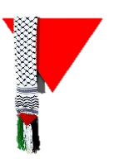
هالة قوريش
خرّيجة دفعة طوفان الأقصى

Dedication
My very special dedicate this work should go to the one person to whom I owe everything I am today, my father Tahar and to my dear mother Namira for helpful advice, care, and affection. I dedicate this work to :
My best brothers Issam, Abderrahime, and Akram
My best sister Hanane and her son Racim
To all my family : Boumissa
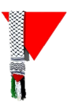
Hadjer

LIST OF CONTENTS
Abstract
Abbreviation list
Figures and Tables list
1. Introduction 1
2. Materials and Methods 5
2.1. Chemical reagents 5
2.2. Plant material collection 5
2.3. Plant extraction 5
2.4. Extraction yield 5
2.5. Phytochemical screening 5
2.5.1. Phnolic test 6
2.5.2. Flavonoids test 6
2.5.3. Saponins test 6
2.5.4. Quinones test 6
2.5.5. Terpenoids test 6
2.5.6. Anthraquinones test 6
2.6. Total Phenolics Content (TPC) 7
2.7. Total Flavonoids Content (TFC) 7
2.8. Evaluation of the antioxidant activity of the plant 8
2.8.1. DPPH Radical Scavenging Activity Assay 8
2.8.2. Ferric reducing antioxidant power (FRAP) 9
2.8.3. Total antioxidant capacity (TAC) 9
3. Results and discussion 11
3.1. Extraction yield 11
3.2. Phytochemical screening 11
3.3. Polyphenols and Flavonoids Content 11
3.5. Antioxidant Activity 12
3.5.1. DPPH radical scavenging 13
3.5.2. The ferric reducing antioxidant power 14
3.5.3. The total antioxidant capacity 17
4. Conclusion 19
5. Bibliographic References 21

ملخص
Scrophularia scorodoniaهو نوع عشبي ينتمي إلى فصيلة الخَنازيريّات (Scrophulariaceae)، ويُستخدم تقليديًا في الطّبّ الشّعبي ويُعرف بتركيبته الكيميائيّة النّباتيّة الغنيّة. تهدف هذه الدراسة إلى التّحقّق من الخصائص المضادّة للأكسدة لنبات S. scorodonia، من خلال التّركيز على استخلاص وتحديد كميّة المركّبات الفينوليّة والفلافونويديّة فيه، بالإضافة إلى تقييم نشاطه المضادّ للأكسدة باستخدام تحليلات مخبريّة .(in vitro) تمّ الحصول على مستخلص مائي كحولي (70٪ إيثانول) عن طريق نقع الأجزاء الهوائيّة للنّبتة، كما أُجري تحليل كيميائي نباتي للكشف عن أهمّ أصناف مواد الأيض الثّانوية. تمّ تحديد المحتوى الكلّي للفينولات (TPC) والمحتوى الكلّي للفلافونويدات (TFC) باستخدام طريقتي فولين-سيوكالتيه وطريقة كلوريد الألمنيوم اللّونية، على التّوالي. وقد تمّ تقييم النّشاط المضادّ للأكسدة من خلال ثلاث اختبارات متكاملة: اختبار تثبيط جذر DPPH، واختبار القدرة المختزلة للحديد (FRAP)، واختبار السّعة الكلّيّة المضادّة للأكسدة (TAC). بلغ مردود الاستخلاص 12.44٪، وكشف التّحليل الكيميائي النّباتي عن وجود البوليفينولات، والفلافونويدات، والكينونات. وُجد أنّ المحتوى الكلّي للفينولات يبلغ 60 ± 0.12 ملغ مكافئ حمض غاليك/غ من المستخلص، في حين أنّ المحتوى الكلّي للفلافونويدات بلغ 26 ± 0.054 ميكروغرام مكافئ كيرسيتين/ملغ من المستخلص. أظهر اختبار DPPH نشاطًا مانعًا للجذور الحرّة يعتمد على التّركيز، بقيمة IC₅₀ = 56.21 ميكروغرام/مل، مقارنة بـ 6.97 ميكروغرام/مل لمركّب BHA المرجعي. أمّا اختبار FRAP فقد أظهر قدرة اختزالية قصوى بلغت 13.36 ميكروغرام مكافئ كيرسيتين/مل مع قيمة EC₅₀ قدرها 296.38 ± 47.55 ميكروغرام/مل، بينما أظهر اختبار TAC أنّ القدرة الكلّيّة للمستخلص على مقاومة الأكسدة تعادل 44.73٪ و37.65٪ من قدرة حمض الأسكوربيك والكيرسيتين، على التّوالي. تُبرز هذه النّتائج القدرة المضادّة للأكسدة المهمّة لنبتة S. scorodonia، ممّا يدعم استخدامها التّقليدي ويشجّع على إجراء مزيد من الدّراسات المستقبليّة.
الكلمات المفتاحية: Scrophularia scorodonia، النّشاط المضادّ للأكسدة، البوليفينولات، الفلافونويدات، DPPH، FRAP، TAC.

Abstract
Scrophularia scorodonia, a herbaceous species belonging to the Scrophulariaceae family, has been traditionally used in folk medicine and is known for its rich phytochemical composition. The present study aimed to investigate the antioxidant properties of S. scorodonia plant, focusing on the extraction and quantification of its phenolic and flavonoid compounds, as well as evaluating its antioxidant activity using in vitro assays. A hydroalcoholic extract (70% ethanol) was obtained by maceration of the aerial parts of the plant, and phytochemical screening was performed to identify major classes of secondary metabolites. Total phenolic content (TPC) and total flavonoid content (TFC) were determined using the Folin–Ciocalteu and aluminum chloride colorimetric methods, respectively. Antioxidant activity was assessed through three complementary assays: DPPH radical scavenging, ferric reducing antioxidant power (FRAP), and total antioxidant capacity (TAC). The extraction yield was 12.44%. Phytochemical screening revealed the presence of polyphenols, flavonoids, and quinones. The TPC was found to be 60 ± 0.12 mg GAE/g extract, while TFC was 26 ± 0.054 µg QE/mg extract. The DPPH assay showed a dose-dependent radical scavenging activity with an IC₅₀ of 56.21 µg/mL, compared to 6.97 µg/mL for BHA. The FRAP assay indicated a maximum reducing power of 13.36 µg QE/mL with an EC₅₀ value of 296.38 ± 47.55 μg/mL, and the TAC assay demonstrated 44.73% and 37.65% of the antioxidant capacity of ascorbic acid and quercetin, respectively. These results highlight the significant antioxidant potential of S. scorodonia, supporting its traditional use and encouraging future investigations.
Keywords: Scrophularia scorodonia, antioxidant activity, polyphenols, flavonoids, DPPH, FRAP, TAC.

Abbreviations list
BHA: Butylhydroxyanisol
DPPH: 2,2-diphenyl-1-picryl-hydrazyl
EC₅₀: Effective concentration at 50%
FRAP: Ferric Reducing Antioxidant Power
GAE: Gallic Acid Equivalent
IC₅₀: Inhibitory Concentration at 50%
QE: Quercetin Equivalent
R²: Correlation coefficient
ROS: Reactive Oxygen Species
RNS: Reactive Nitrogen Species
S. scorodonia: Scrophylaria scorodonia
TAC: Total Antioxidant Capacity
TFC: Total Flavonoid Content
TPC: Total Phenolic Content

List of figures and tables
Figures
Figure 1: Aerial part of S. scorodonia 3
Figure 2: Standard curve of gallic acid for the quantification of total polyphenols 7
Figure 3: Standard curve of quercetin for determination of total flavonoids 8
Figure 4: Percentage of DPPH inhibition as a function of the concentration of the ethanolic extract of S. scorodonia 14
Figure 5: Percentage of DPPH inhibition as a function of the concentration of the BHA 14
Figure 6: Calibration curve of the reducing power of quercetin 16
Figure 7: Calibration curve of the reducing power of S. scorodonia ethanolic extract 16
Figure 9: Histogram of the total antioxidant capacity (TAC) of S. scorodonia extract compared to quercetin 17
Figure 8: Histogram of the total antioxidant capacity (TAC) of S. scorodonia extract compared to ascorbic acid 17

Tables
Table 1: Ferric reducing antioxidant power of S. scorodonia ethanolic extract expressed as quercetin equivalents (QE) 15


Introduction

Introduction
Oxidative stress is a pathological processe resulting from an imbalance between reactive oxygen and nitrogen species (ROS/RNS) and the body’s antioxidant defense mechanisms. This imbalance promotes inflammation, leads to cellular damage with significant biological consequences that impact key biomolecules, including nucleic acids, lipids, and proteins (Ames et al., 1993; Azadmehr et al., 2013; Kotha et al., 2022; Shabbir et al., 2024).
Accordingly, antioxidants play a crucial role in human health, as they can inhibit or delay undesired oxidation reactions, thus preventing oxidative stress related to more than 100 diseases including cardiovascular disorders, cancer, hypertension, diabetes, neurodegenerative disorders, cancer, and aging-related conditions (Kotha et al., 2022; Rumpf et al., 2023).
Although extensive efforts have been made to identify both natural and synthetic antioxidant agents (Azadmehr et al., 2013), the search for antioxidants from natural sources has garnered considerable attention as researchers seek to identify compounds that can serve as suitable replacements for synthetic ones (Wong et al., 2006). Natural antioxidants can protect the body against oxidative damage and reduce the risk of various chronic diseases (Stanner et al., 2004). The researcher who examined the link between natural antioxidants found in medicinal plants and the decrease in degenerative diseases reached this conclusion. Among these natural substances, phenolic compounds and flavonoids are notable as major groups of antioxidant agents ( Chen et al., 2008; Zhang et al., 2011; Mahboubi et al., 2013; Chaouche et al., 2014).
Polyphenols are a diverse group of secondary metabolites found in plants known for their significant roles in human health and characterized by multiple phenolic structural units (Tijjani et al., 2020; Kim et al., 2023). They are classified into several categories, according to their chemical structure, including phenolic acids, flavonoids, stilbenes, and lignans (Siasos et al., 2013; Tijjani et al., 2020). These compounds are widely distributed in the plant kingdom and are integral to the sensory characteristics of plant-derived foods, such as flavor, astringency, and color. Notable sources of polyphenols include tea, grapes, olive oil, chocolate/cocoa, coffee, walnuts, peanuts, popcorn, pomegranates, and other fruits and vegetables (Landete, 2012).
Flavonoids, the most abundant class of polyphenols, comprise a significant portion (≈4000 out of 8000) of polyphenols already identified, and compose a structure of two aromatic rings, linked by an oxygenated heterocycle. Depending on the oxidation state of the central ring, flavonoids are subclassified as flavonols, flavones, flavanones, flavanols, isoflavones, and anthocyanins (Siasos et al., 2013; Galanakis, 2021). Research indicates that polyphenols exhibit a range of biological activities, including antioxidant, anti-inflammatory, antimicrobial, and anticancer properties (Kowalska et al., 2017).
In recent years, there has been a significant increase in the use of medicinal plants and crude extracts, reflecting a growing interest in natural therapeutic agents (Galíndez et al., 2000). Among these, the Scrophularia genus has attracted considerable scientific attention, with a notable rise in research focused on its metabolites, pharmacological activities, and traditional medicinal applications (Pasdaran and Hamedi, 2017).
The Scrophularia genus, one from about 222 genera within a large cosmopolitan family ; Scrophulariaceae (Kingdom: Plantae, Phylum : Angiosperms, Class : Eudicots, Order : Lamiales), comprises approximately 300 species commonly known as figwort (Tank et al., 2006; Asmat et al., 2011; Pasdaran and Hamedi, 2017). Many of these species have long been used in traditional medicine to treat various conditions, including scrofula, scabies, tumors, and inflammatory disorders. Phytochemical investigations have identified a wide array of secondary metabolites in this genus, such as iridoids, phenylpropanoids, phenolic acids, flavonoids, and saponins, each contributing to diverse biological activities, including anti-inflammatory, antioxidant, antibacterial, hepatoprotective, immunomodulatory, cardioprotective, diuretic, fungicidal, cytotoxic, and antitumor effects.
Despite this rich phytochemical diversity, only 17 species within the genus have been extensively studied. Moreover, a limited number of isolated metabolites have been subjected to detailed biological evaluation, indicating the need for further phytochemical and pharmacological research (Pasdaran and Hamedi, 2017).
Scrophularia scorodonia L. (S. scorodonia), a noteworthy and underexplored species primarily distributed in shaded and coastal regions of Western Europe and North Africa, including Belgium, Ireland, Spain, Tunisia, and the Canary Islands. S. scorodonia (figure 1) is a herbaceous plant that can grow up to one meter in height, characterized by pubescent quadrangular stems, and rugose doubly crenate leaves. Its reddish-brown flowers are arranged in terminal leafy panicles, contributing to its distinctive botanical profile (Anonymous 1, 2011).
The antioxidant potential of many medicinal herbs has been demonstrated, including some Scrophularia species that have significant antioxidant activity (Schinella et al., 2002). Previous studies have reported that S. scorodonia exhibits both antioxidant and anti-inflammatory properties, which support its potential medicinal value (Dı́az et al., 2004; Fernandez et al., 1995). Several of them have highlighted its bioactive components and their effects, particularly phenylpropanoid glycosides such as angoroside A, C, and D, along with acteoside and isoacteoside (Dı́az et al., 2004). Iridoids like Buddlejasaponin I (Galindez et al., 2001; Galíndez et al., 2002), scorodioside, and 8-O-cis-cinnamoylharpagide have also been isolated (Fernandez et al., 1995).
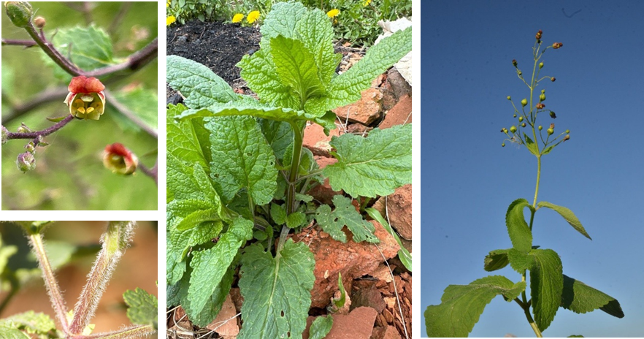
Based on these insights, this study aims to provide a comprehensive analysis of Scrophularia scorodonia, focusing on the ethanolic extraction and quantification of its major bioactive constituents, particularly polyphenols and flavonoids, while evaluating its antioxidant and anti-inflammatory activities. These activities will be assessed using in vitro assays, including DPPH, FRAP, and TAC tests for antioxidant capacity.
Figure 1: Aerial part of S. scorodonia (Anonymous 2)

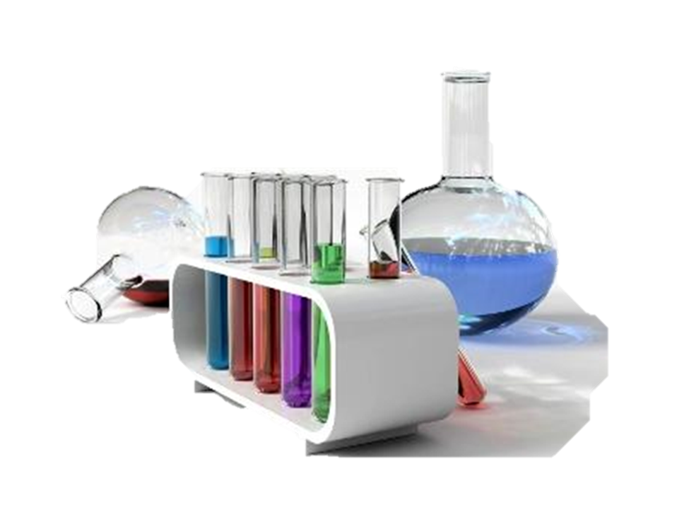
Materials and Methods

Materials and Methods

2.1. Chemical reagents
Chemicals used in this study: ethanol, methanol, ferric chloride (FeCl₃), ammonia (NH₄OH), sulfuric acid (H₂SO₄), chloroform, chloredric acid (HCl), Folin-Ciocalteu, sodium carbonate (Na₂CO₃) solution, gallic acid, aluminum trichloride (AlCl₃), quercetin,2,2-diphenyl-1-picryl-hydrazyl (DPPH) phosphate buffer, potassium ferricyanide solution, trichloroacetic acid (TCA), sodium phosphate (Na₃PO₄), ammonium molybdate ((NH₄) ₆ Mo₇ O₂₄·4H₂O), butylhydroxyanisol (BHA), and ascorbic acid were obtained from Sigma (Germany). These reagents were of analytical grade and were used as received without further purification.

2.2. Plant material collection
The S. scorodonia plant considered in this research was collected from the eastern heights of Algeria in the Ain Sebt village in early June 2024. The aerial part was then dried in the shade and powdered using a grinder, and prepared for extraction.

2.3. Plant extraction
The extraction of bioactive compounds from S. scorodonia is a critical initial step in harnessing its therapeutic potential. In this study, ethanol was selected as the solvent for the extraction of S. scorodonia: 20 grams of dry powder of leaves, stems, and flowers (aerial parts) were dissolved by maceration in 200 mL of 70% ethanol and kept in the dark for 24 h. The macerate solvent was then filtered through Whatman paper and concentrated on a vacuum rotary evaporator at a temperature of 40 °C. The extract was recovered by drying in an oven and stored in the dark until use.

2.4. Extraction yield
The extraction yield, represented by Y (%), is indeed calculated as the ratio of the weight of the extract obtained (WE) to the weight of the dry plant material used (WP), multiplied by 100 (Y% = (WE/ WP) ×100). This formula effectively provides the percentage of the desired compounds extracted from the plant material (Macías-Cortés et al., 2022).

2.5. Phytochemical screening
Specific phytochemical assays were conducted to assess the presence or absence of compounds associated with various classes of secondary metabolites. These tests relied on characteristic color changes, turbidity, or precipitation reactions, following standardized methods reported in the literature: polyphenols (Guessan et al., 2009), terpenes, saponins (Haddouchi et al., 2018), quinones, flavonoids and anthraquinones (Boudoukha et al., 2024).

2.5.1. Phnolic test
The presence of polyphenols is detected by adding one or two drops of a 2% methanolic solution of ferric chloride (FeCl₃) to 1 mL of the plant extract. The appearance of a green color, of varying intensity, indicates a positive reaction.

2.5.2. Flavonoids test
To 1 mL of extract, 0.5 mL of concentrated sulfuric acid was added, followed by 0.5 mL of ammonia (NH₄OH). If the color increases in the presence of acid and turns blue or purplish blue in a basic medium, this indicates the presence of flavonoids.

2.5.3. Saponins test
Their presence is qualitatively determined by the foam test. In a test tube, add 2 mL of distilled water to 1 mL of the extract. Shake the mixture vigorously for 30 seconds; the formation of a persistent, stable foam during this time indicates the presence of saponins.

2.5.4. Quinones test
0.5 mL of concentrated sulfuric acid is added to 1 mL of the extract. The appearance of a red color confirms the presence of quinones.

2.5.5. Terpenoids test
1 mL of the extract is added to 4 mL of chloroform, followed by the addition of a few drops of concentrated sulfuric acid. The formation of a reddish-brown ring at the interface indicates a positive test.

2.5.6. Anthraquinones test
A few drops of HCl (2%) are added to 1 mL of the extract. The formation of a red precipitate indicates the presence of anthraquinones.

2.6. Total Phenolics Content (TPC)
The total phenolic content of the extract was quantified using the Folin–Ciocalteu colorimetric method (Kim et al., 2006). Each 0.2 mL of diluted extract (1 mg/mL) was mixed with 1 mL of the Folin–Ciocalteu reagent and 0.2 mL of a saturated sodium carbonate (Na₂CO₃) solution. The resulting mixture was left to stand in the dark at room temperature for two hours. Following incubation, the absorbance was measured at 765 nm using a UV-V spectrophotometer (figure 2), and the total phenolic content was determined and expressed as micrograms of gallic acid equivalents (GAE) per millilitre of solution.
Figure 2: Standard curve of gallic acid for the quantification of total polyphenols

2.7. Total Flavonoids Content (TFC)
The total flavonoid content was determined using the aluminum chloride colorimetric method (Amari et al., 2025), where 1 mL of each sample was mixed with 1 mL of 2% aluminum chloride (AlCl3) solution. After 10 minutes of further incubation, the absorbance was recorded at 430 nm against a blank using a UV-Vis spectrophotometer. The amount of total flavonoid was calculated from a standard curve of quercetin, and expressed as micrograms of quercetin equivalents per milligram of extract (μg QE/mg extract).
Figure 3: Standard curve of quercetin for determination of total flavonoids

2.8. Evaluation of the antioxidant activity of the plant

2.8.1. DPPH Radical Scavenging Activity Assay
The antioxidant activity of various compounds or plant extracts was assessed using the stable free radical 2,2-diphenyl-1-picrylhydrazyl (DPPH°), which exhibits a deep violet color in its radical form due to a characteristic absorption band. Upon interaction with an antioxidant (AH) or a radical species (R°), DPPH° undergoes a reduction reaction, resulting in a discoloration that corresponds to a decrease in absorbance. The extent of this decrease is proportional to the scavenging ability of the tested substance. The general reaction mechanisms are as follows: DPPH° + AH → DPPH-H + A°, and DPPH° + R° → DPPH- (Brand-Williams et al., 1995).
The antioxidant activity of the ethanolic extract of S. scorodonia was evaluated following the method originally described by Blois (1958), with slight modifications. A 0.1 mM DPPH solution was prepared in methanol, and 0.5 mL of this solution was added to the volume of plant extract at various concentrations (20–300 µg/mL) preparing from the stock solution (1mg/mL). The mixtures were incubated in the dark at room temperature for 30 minutes to prevent light-induced degradation of DPPH radicals. After incubation, the absorbance was measured at 517 nm using a spectrophotometer. The percentage of DPPH radical inhibition was calculated using the following formula : % Inhibition= Abs ₍DPPH₎ – Abs ₍Sample₎ / Abs ₍DPPH₎ ×100
Where: Abs ₍DPPH₎: absorbance of the DPPH solution without extract (control).
Abs ₍Sample₎: absorbance of the DPPH solution with the test extract.
The IC₅₀ value, the concentration of extract required to inhibit 50% of DPPH radicals, was determined and calculated using the exponential regressions curve. This curve was constructed by plotting the percentage inhibition against the tested concentrations.

2.8.2. Ferric reducing antioxidant power (FRAP)
The ferric reducing antioxidant power of the plant extract is evaluated based on its ability to donate electrons, converting ferric ions (Fe³⁺) into ferrous ions (Fe²⁺). This redox reaction reflects the presence of antioxidant compounds within the extract. The assay was carried out following the method originally described by Oyaizu (1986), as cited by Haddouchi et al., (2018), with slight modification. Briefly, 0.5 mL of the plant extract at various concentrations was mixed with 1.25 mL of phosphate buffer (0.2 M, pH 6.6) and 1.25 mL of potassium ferricyanide solution (1%). The mixture was incubated at 50°C for 20 minutes. After incubation, 1.25 mL of trichloroacetic acid (TCA, 10%) was added to terminate the reaction, followed by agitation to ensure proper mixing. Subsequently, 1.25 mL of the resulting solution was mixed with 1.25 mL of distilled water and 0.25 mL of ferric chloride solution (FeCl₃, 0.1%). The absorbance of the final mixture was measured at 700 nm using a UV-Vis spectrophotometer. A higher absorbance indicates a greater reducing power of the extract. Quercetin was used as the reference standard and processed under identical conditions.

2.8.3. Total antioxidant capacity (TAC)
The total antioxidant capacity (TAC) of S. scorodonia extracts was determined using the phosphomolybdic method (Prieto et al., 1999). 0.3 mL of the extract (1 mg/mL) was mixed with 3.0 mL of a reagent solution containing 0.6 M sulfuric acid (H₂SO₄), 28 mM sodium phosphate (Na₃ PO₄), and 4 mM ammonium molybdate ((NH₄) ₆ Mo₇ O₂₄·4H₂O). The mixture was incubated in a 95°C water bath for 90 min. After cooling to room temperature, the absorbance was measured at 695 nm using a UV-Visible spectrophotometer against a blank containing only the reagent solution and solvent. The total antioxidant capacity was expressed in quercetin or ascorbic acid (vitamin C) equivalents, which were used as reference standards and considered to represent 100% of the total antioxidant capacity. The TAC (%) values of the extracts were calculated using the following formula:
TAC (%) = (Absorbance of sample / Absorbance of quercetin or ascorbic acid) × 100


Results and discussions

Results and discussion

3.1. Extraction yield
The extraction process is critical in obtaining high yields of bioactive compounds. In the present study, the extract of S. scorodonia aerial part was prepared by maceration using ethanol solvent. The estimation of yield to the total powder weight (100 g) of the plant shows a value of 12.44%.
It is difficult to compare our results with those in the literature, as the extract yield varies depending on the method and conditions under which the extraction was carried out, the species and geographical origin of the plant, the storage conditions and duration, as well as the harvesting period (Haddouchi et al., 2018). Various techniques have been employed to optimize the extraction from plant materials (Wang et al., 2020; Macías-Cortés et al., 2022). The choice of solvent also plays a significant role in the yield and type of extracted compounds (Herrera-Rocha et al., 2022; Macías-Cortés et al., 2022).

3.2. Phytochemical screening
The experimental results from the phytochemical screening tests for the ethanolic extract of S. scorodonia revealed the presence of polyphenols, flavonoids, and quinones, while terpenoids, anthraquinones, and saponins showed negative results.
The presence of polyphenols and flavonoids in the aerial parts of S. scorodonia is supported by the findings of other scrophularia species: S. frutescens, S. grossheimi, S. koelzii, S. nodosa, S. sambucifolia. However, saponins, which are absent in our plant, are present in most of these species and others as well (Galíndez et al., 2002), and the terpenoids are revealed in the phytochemical analysis of S. frigida (Asgharian et al., 2015), taking into consideration the extracted part (aerial, roots) and the solvent used. As for the results regarding the other components, to the best of our research, we did not find any studies to support them.

3.3. Polyphenols and Flavonoids Content
Quantifying the total phenolic and flavonoid content is essential for assessing the quality and potential bioactivity of the extract. Spectrophotometric methods are commonly used for this purpose (Belarbi et al., 2017; Kim et al., 2023). These methods provide a measure of the antioxidant capacity, which is crucial for understanding the extract's ability to neutralize free radicals and reduce oxidative stress (Shiri et al., 2023).
The total phenolic content of the ethanolic extract of S. scorodonia was determined using the Folin-Ciocalteu method and expressed as milligrams of gallic acid equivalents per gram of extract (mg GAE/g). Based on the calibration curve equation (y = 0.0195x + 0.0689; R² = 0.9951), the phenolic content was found to be 60 ± 0.12 mg GAE/g extract.
Similarly, the total flavonoid content was assessed using the aluminum chloride colorimetric method and expressed as milligrams of quercetin equivalents per gram of extract (mg QE/g). The ethanolic extract of S. scorodonia contained 26 ± 0.054 mg QE/g extract.
When compared to similar studies on Scrophularia species, our findings are within a comparable range. For instance, S. striata showed a TPC of 79.7 mg GAE/g in ethanolic extract and reached the highest reported value of 158.33 ± 6.03 mg GAE/g in hydroalcoholic extract. As for TFC, values ranged from 9.8 to 66.26 ± 4.33 mg QE/g (Mahboubi et al., 2013; Jafari et al., 2014). In the case of S. lucida, the TPC was highest in aqueous extract (29.31 mg GAE/g extract), while the highest TFC (48.33 mg rutin equivalent/g extract) was observed in the ethyl acetate extract (Zengin et al., 2019).
These variations reflect the influence of extraction solvent, plant part used, and interspecies phytochemical diversity. Nevertheless, the current results confirm the moderate to rich phenolic and flavonoid content of S. scorodonia.

3.5. Antioxidant Activity
Antioxidants play a crucial role in protecting biological systems against oxidative stress (Rumpf et al., 2023). They act primarily through three mechanisms: hydrogen atom transfer, single electron transfer, and metal chelation. These mechanisms allow them to intervene at different stages of oxidative processes: by preventing radical formation, interrupting radical chain reactions, or inactivating reactive species. The body’s defense relies on both endogenous enzymatic antioxidants (superoxide dismutase, catalase, and glutathione peroxidase…), and non-enzymatic compounds (glutathione and lipoic acid…). Exogenous antioxidants, including polyphenols, flavonoids, and vitamins, also contribute significantly to neutralizing free radicals (Kotha et al., 2022).
To evaluate antioxidant activity in vitro, several spectrophotometric methods are commonly used. In this study, the DPPH radical scavenging assay, ferric reducing antioxidant power (FRAP), and total antioxidant capacity (TAC) were employed to provide reliable indications of the radical-scavenging and reducing abilities of S. scorodonia plant extract.

3.5.1. DPPH radical scavenging
The DPPH radical is characterized by its intense purple color, and the efficiency of an antioxidant is evaluated by its ability to reduce this coloration through hydrogen or electron donation (Molyneux, 2004). The free radical scavenging activity of the ethanolic extract of S. scorodonia was evaluated by determining the IC₅₀ (μg/mL) and compared to that of BHA. The IC₅₀ value is defined as the concentration of the extract that inhibits 50% of the DPPH radical. This value is calculated by modeling the percentage inhibition as a function of the extract concentration using the exponential equation. Since IC₅₀ is inversely associated with the anti-radical activity, a lower IC₅₀ value indicates higher antioxidant activity ( Zargoosh, 2019).
As shown in Figure 4, the ethanolic extract of S. scorodonia exhibited a clear dose-dependent antioxidant activity, with increasing percentages of DPPH radical inhibition observed at concentrations ranging from 20 to 300 µg/mL. The IC₅₀ value obtained (56.21 ± 6.84 µg/mL) suggests a considerable to strong scavenging ability, although it remains higher than that of the synthetic standard BHA (IC₅₀ = 6.97 ± 1.34 µg/mL; Figure 5).
To the best of our knowledge, specific studies on S. scorodonia are virtually non-existent in the literature, which gives particular value to these findings. Compared to other Scrophularia species, the IC₅₀ value of our extract highlights a relatively higher antioxidant potential and notable free-radical scavenging activity. For instance, previous studies on S. striata reported significantly higher IC₅₀ values: 240 µg/mL for 70% ethanolic extracts (Mahboubi et al., 2013), 407 µg/mL for hydroalcoholic extracts (Jafari et al., 2014), and 920 µg/mL (± 210) for methanolic extracts (Shahbazi, 2017). In contrast, the essential oil of S. amplexicaulis demonstrated a much stronger antioxidant with IC₅₀ = 4.41 μg/mL (Pasdaran et al., 2012).
These comparative values reflect the variability in antioxidant activity within the genus Scrophularia, depending on the species and extraction method, and support the notable potential of S. scorodonia as a natural source of antioxidants. This activity is likely due to its richness in phenolic compounds, which are well known for their key role in neutralizing free radicals, as several studies have established the strong link between high phenolic content and antioxidant activity in plants (Kerdar et al., 2018).
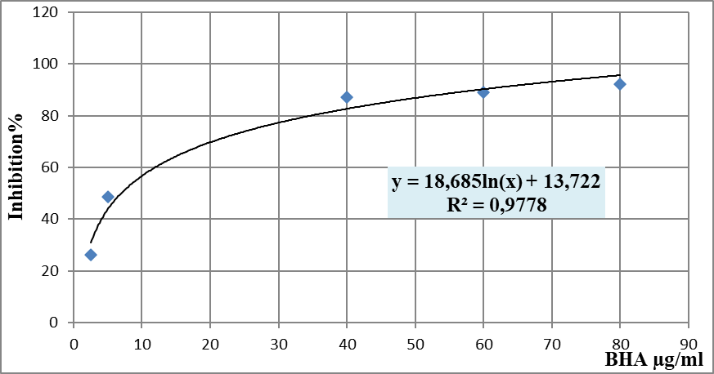
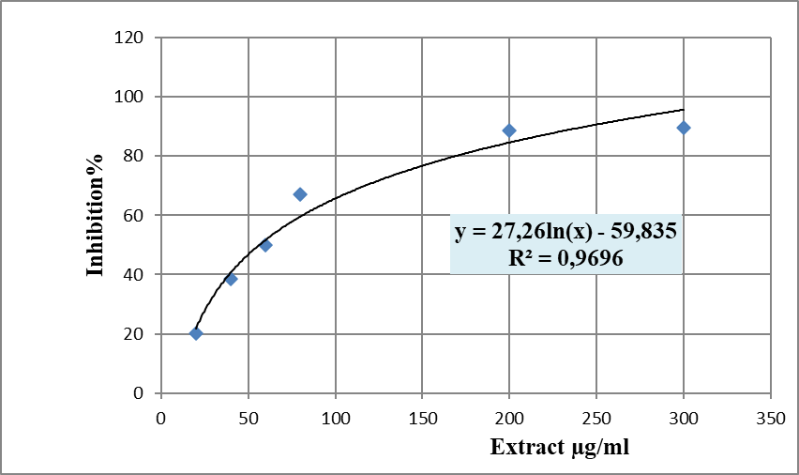
Figure 4 : Percentage of DPPH inhibition as a function of the concentration of the ethanolic extract of S. scorodonia
Figure 5: Percentage of DPPH inhibition as a function of the concentration of the BHA

3.5.2. The ferric reducing antioxidant power
In the FRAP assay, antioxidants reduce ferric ions (Fe³⁺) to ferrous ions (Fe²⁺) by donating electrons. The concentration of antioxidant compounds in the extract was assessed by determining the effective concentration at 50% (EC₅₀), defined as the amount of extract required to produce an absorbance value of 0.5. The results, as illustrated in the calibration curves (Figures 6 and 7), showed that the ferric reducing capacity increased proportionally with the concentration of the extract, as well as for the quercetin reference standard, with an EC₅₀ value of 296.38 ± 47.55 μg/mL and 32.72 ± 0.6 μg/mL, respectively. When expressed in quercetin equivalents (Table 1), the reducing power of the extract reached 13.36 µg QE/mL at 100 µg/mL, indicating a moderate electron-donating ability and confirming the concentration-dependent activity. These findings suggest that the extract possesses a capacity to act as a reductant, a key mechanism in antioxidant defense. The strong linearity of the quercetin calibration curve (R² = 0.9989) further supports the reliability of this measurement.
Despite the moderate reducing capacity observed in the ethanolic extract of S. scorodonia, supporting this result through direct comparisons remains challenging due to the limited number of studies available on this particular species, as well as the overall scarcity of data within the Scrophularia genus. Furthermore, the few existing studies often express FRAP results using different units, such as mg of Trolox equivalents per gram of extract or mmol of FeSO4/g of extract (Safavi et al., 2012; Zengin et al., 2019; Shiri et al., 2023), making direct numerical comparison difficult. Therefore, this study relies primarily on general findings across the genus, which consistently report the presence of antioxidant activity in various Scrophularia species. These general trends reinforce the relevance of the antioxidant potential detected in S. scorodonia, even if exact quantitative alignment cannot be established.
Table 1: Ferric reducing antioxidant power of S. scorodonia ethanolic extract expressed as quercetin equivalents (QE)
[Extract] (µg/mL) | 10 | 20 | 60 | 80 | 100
Absorption (700 nm) | 0.0685 | 0.099 | 0.1585 | 0.1765 | 0.2095
QE (µg/mL) | 4.37 | 6.32 | 10.11 | 11.25 | 13.36
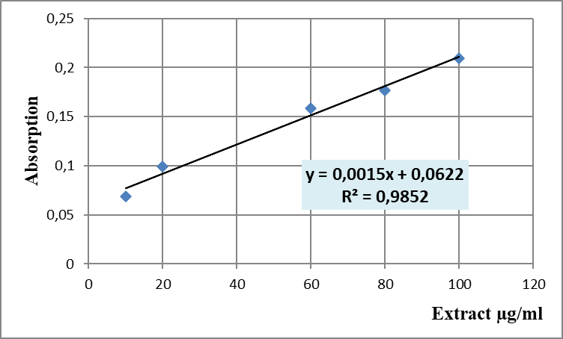
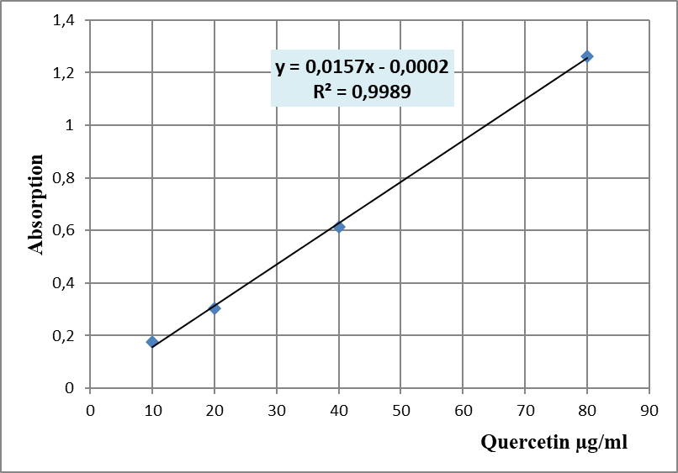
Figure 6: Calibration curve of the reducing power of S. scorodonia ethanolic extract
Figure 7: Calibration curve of the reducing power of quercetin

3.5.3. The total antioxidant capacity
To evaluate the total antioxidant capacity of the ethanolic extract of S. scorodonia, the phosphomolybdate assay was employed. In this method, ascorbic acid (vitamin C) and quercetin were used as reference antioxidants, each representing 100% antioxidant potential.
As shown in Figures 8 and 9, the S. scorodonia extract exhibited a moderate antioxidant activity, demonstrating 37.65% compared to quercetin and 44.73% of the antioxidant potential of ascorbic acid.
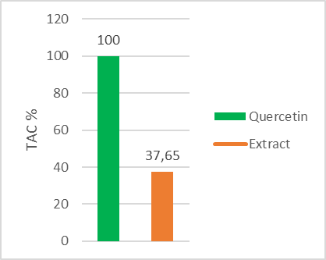
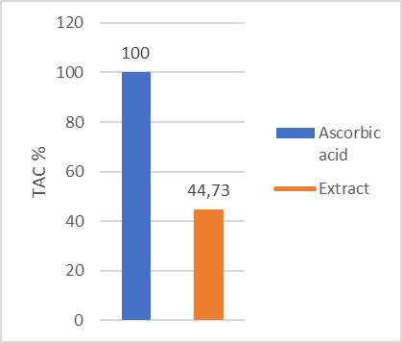
To the best of our knowledge, no specific studies have been conducted on the total antioxidant capacity of S. scorodonia. Moreover, data on TAC values across the Scrophularia genus remain scarce and heterogeneous, often reported using different methodologies and units, which complicates direct comparison. Nonetheless, existing studies on related species such as S. lucida (Zengin et al., 2019), suggest that members of this genus generally possess antioxidant potential, supporting the relevance of the activity observed in the present extract.
Figure 8: Histogram of the total antioxidant capacity (TAC) of S. scorodonia extract compared to quercetin
Figure 9: Histogram of the total antioxidant capacity (TAC) of S. scorodonia extract compared to ascorbic acid

It is interesting to note that the S. scorodonia plant demonstrated significant antioxidant activity across the three evaluation methods, which is likely attributed to the high content of phenolic and flavonoid, the major groups of compounds acting as primary antioxidants or free radical terminators (Chen et al., 2008). This correlation reinforces the widely documented relationship between phenolic composition and antioxidant efficacy in medicinal plants and supports the hypothesis that phenolic-rich species within the Scrophularia genus may serve as promising sources of natural antioxidants (Kerdar et al., 2018).

Conclusion

Conclusion
The present study demonstrated that Scrophularia scorodonia possesses notable antioxidant activity. This was clearly reflected in the results of the DPPH, FRAP, and TAC assays, which revealed a strong radical scavenging capacity and reducing power. This antioxidant potential is largely attributed to the plant’s high content of polyphenols and flavonoids, bioactive compounds well known for their protective effects against oxidative stress.
These findings demonstrate the therapeutic relevance of Scrophularia scorodonia and underscore the need for further investigations to fully explore its pharmacological potential. In light of this, future research should focus on:
- Isolate and characterize the plant’s bioactive compounds through advanced phytochemical techniques.
- Optimize extraction efficiency by comparing different solvents and techniques under controlled conditions.
- Clarify the mechanisms of action of these compounds using molecular and cellular-level studies.
- Assess biological safety and efficacy through in vivo models, toxicological testing, and properly designed clinical trials.

Bibliographic References


Bibliographic References
Amari, S., Karbab, A., Charef, N., & Arrar, L. (2025). Antioxidant, antimicrobial activities and phytochemical analysis of Erica arborea L. stem extracts. Research Journal of Pharmacy and Technology, 18(2). https://doi.org/10.52711/0974-360X.2025.00112
Ames, B. N., Shigenaga, M. K., & Hagen, T. M. (1993). Oxidants, antioxidants, and the degenerative diseases of aging. Proceedings of the National Academy of Sciences, 90(17), 7915–7922. https://doi.org/10.1073/pnas.90.17.7915
Anonymous 1. (2011). https://www.tela-botanica.org/eflore/?referentiel=bdtfx&module=fiche&action=fiche&num_nom=62039&onglet=synthese
Anonymous 2. Scrophularia scorodonia L., Scrofulaire scorodoine (Flore mondiale) - Pl@ntNet identify
Asgharian, P., Heshmati Afshar, F., Asnaashari, S., Bamdad Moghaddam, S., Ebrahimi, A., & Delazar, A. (2015). Characterization of terpenoids in the essential oil extracted from the aerial parts of Scrophularia subaphylla growing in Iran. Advanced Pharmaceutical Bulletin, 5(4), 557–561. https://doi.org/10.15171/apb.2015.075
Azadmehr, A., Alizadeh Oghyanous, K., Hajiaghaee, R., Amirghofran, Z., & Azadbakht, M. (2013). Antioxidant and neuroprotective effects of Scrophularia striata extract against oxidative stress-induced neurotoxicity. Cellular and Molecular Neurobiology, 33(8), 1135–1141.https://doi.org/10.1007/s10571-013-9979-7
Belarbi, K., Atik-Bekkara, F., El Haci, I. A., Bensaid, I., Beddou, F., & Bekhechi, C. (2017). In vitro antioxidant activity and phytochemical analysis of Teucrium pseudo-scorodonia Desf. collected from Algeria. Oriental Pharmacy and Experimental Medicine, 17(2), 151–160. https://doi.org/10.1007/s13596-017-0260-3
Blois, M. S. (1958). Antioxidant determinations by the use of a stable free radical. Nature, 181(4617), 1199–1200. https://doi.org/10.1038/1811199a0
Boudoukha, C., Amor, L., Nouioua, W., Daif, A. S., & Belhattab, R. (2024). Polyphenol content, antioxidant capacity and protein level effects of beetroot and carob-based pre-workout. Brazilian Journal of Animal and Environmental Research, 7(4), e75247. https://doi.org/10.34188/bjaerv7n4-101
Brand-Williams, W., Cuvelier, M. E., & Berset, C. (1995). Use of a free radical method to evaluate antioxidant activity. LWT - Food Science and Technology, 28(1), 25–30. https://doi.org/10.1016/S0023-6438(95)80008-5
Chaouche, T. M., Haddouchi, F., Ksouri, R., & Atik-Bekkara, F. (2014). Evaluation of antioxidant activity of hydromethanolic extracts of some medicinal species from South Algeria. Journal of the Chinese Medical Association, 77(6), 302–307. https://doi.org/10.1016/j.jcma.2014.01.009
Chen, X. N., Fan, J. F., Yue, X., Wu, X. R., & Li, L. T. (2008). Radical scavenging activity and phenolic compounds in persimmon (Diospyros kaki L. cv. Mopan). Journal of Food Science, 73(1). https://doi.org/10.1111/j.1750-3841.2007.00587.x
De Santos Galíndez, J., Díaz Lanza, A. M., & Fernández Matellano, L. (2002). Biologically active substances from the genus Scrophularia. Pharmaceutical Biology, 40(1), 45–59. https://doi.org/10.1076/phbi.40.1.45.5864
De Santos Galíndez, J., Fernández Matellano, L., Díaz Lanza, A. M., & Villaescusa Castillo, L. (2000). Seasonal variations in the harpagoside content of Scrophularia scorodonia L. Zeitschrift für Naturforschung C, 55(11–12), 1035–1037. https://doi.org/10.1515/znc-2000-11-1231
Díaz, A. M., Abad, M. J., Fernández, L., Silván, A. M., De Santos, J., & Bermejo, P. (2004). Phenylpropanoid glycosides from Scrophularia scorodonia: In vitro anti-inflammatory activity. Life Sciences, 74(20), 2515–2526. https://doi.org/10.1016/j.lfs.2003.10.008
Fernandez, L., Diaz, A. M., Ollivier, E., Faure, R., & Balansard, G. (1995). An iridoid diglycoside isolated from Scrophularia scorodonia. Phytochemistry, 40(5), 1569–1571. https://doi.org/10.1016/0031-9422(95)00305-Q
Galanakis, C. M. (Ed.). (2021). Food bioactives and health. Springer. https://doi.org/10.1007/978-3-030-57469-7
Galíndez, J. D. S., Fernández Matellano, L., & Díaz Lanza, A. M. (2001). Iridoids from Scrophularia genus. Zeitschrift für Naturforschung C, 56(7–8), 513–520. https://doi.org/10.1515/znc-2001-7-807
Haddouchi, F., Chaouche, T. M., & Halla, N. (2018). Screening phytochimique, activités antioxydantes et pouvoir hémolytique de quatre plantes sahariennes d’Algérie. Phytothérapie, 16(S1), S254–S262. https://doi.org/10.3166/phyto-2019-0140
Herrera-Rocha, K. M., Rocha-Guzmán, N. E., Gallegos-Infante, J. A., González-Laredo, R. F., Larrosa-Pérez, M., & Moreno-Jiménez, M. R. (2022). Phenolic acids and flavonoids in acetonic extract from quince (Cydonia oblonga Mill.): Nutraceuticals with antioxidant and anti-inflammatory potential. Molecules, 27(8), 2462. https://doi.org/10.3390/molecules27082462
Kerdar, T., Moradkhani, S., & Dastan, D. (2018). Phytochemical and biological studies of Scrophularia striata from Ilam. Jundishapur Journal of Natural Pharmaceutical Products, 13(3), e62705. https://doi.org/10.5812/jjnpp.62705
Kim, K., Tsao, R., Yang, R., & Cui, S. (2006). Phenolic acid profiles and antioxidant activities of wheat bran extracts and the effect of hydrolysis conditions. Food Chemistry, 95(3), 466–473. https://doi.org/10.1016/j.foodchem.2005.01.032
Kim, K. H., Ki, M.-R., Min, K. H., & Pack, S. P. (2023). Advanced delivery system of polyphenols for effective cancer prevention and therapy. Antioxidants, 12(5), 1048. https://doi.org/10.3390/antiox12051048
Kotha, R. R., Tareq, F. S., Yildiz, E., & Luthria, D. L. (2022). Oxidative stress and antioxidants—A critical review on in vitro antioxidant assays. Antioxidants, 11(12), 2388. https://doi.org/10.3390/antiox11122388
Kowalska, H., Czajkowska, K., Cichowska, J., & Lenart, A. (2017). What’s new in biopotential of fruit and vegetable by-products applied in the food processing industry. Trends in Food Science & Technology, 67, 150–159. https://doi.org/10.1016/j.tifs.2017.06.016
Landete, J. M. (2012). Updated knowledge about polyphenols: Functions, bioavailability, metabolism, and health. Critical Reviews in Food Science and Nutrition, 52(10), 936–948. https://doi.org/10.1080/10408398.2010.513779
Macías-Cortés, E., Gallegos-Infante, J. A., Rocha-Guzmán, N. E., Moreno-Jiménez, M. R., Cervantes-Cardoza, V., Castillo-Herrera, G. A., & González-Laredo, R. F. (2022). Antioxidant and anti-inflammatory polyphenols in ultrasound-assisted extracts from salvilla (Buddleja scordioides Kunth). Ultrasonics Sonochemistry, 83, 105917. https://doi.org/10.1016/j.ultsonch.2022.105917
Mahboubi, M., Kazempour, N., & Boland Nazar, A. R. (2013). Total phenolic, total flavonoids, antioxidant and antimicrobial activities of Scrophularia striata Boiss extracts. Jundishapur Journal of Natural Pharmaceutical Products, 8(1), 15–19.
Molyneux, P. (2004). The use of the stable free radical diphenylpicrylhydrazyl (DPPH) for estimating antioxidant activity. Songklanakarin Journal of Science and Technology, 26(2), 211–219.
N’Guessan, K., Kadja, B., Zirihi, G., Traoré, D., & Aké-Assi, L. (2009). Screening phytochimique de quelques plantes médicinales ivoiriennes utilisées en pays Krobou (Agboville, Côte-d’Ivoire). Sciences & Nature, 6(1), 1–15. https://doi.org/10.4314/scinat.v6i1.48575
Pasdaran, A., Delazar, A., Nazemiyeh, H., Nahar, L., & Sarker, S. D. (2012). Chemical composition, and antibacterial (against Staphylococcus aureus) and free-radical-scavenging activities of the essential oil of Scrophularia amplexicaulis Benth. Records of Natural Products, 6(4), 350–355. https://www.acgpubs.org/doc/2018080715165749-RNP-1107-714.pdf
Pasdaran, A., & Hamedi, A. (2017). The genus Scrophularia: A source of iridoids and terpenoids with a diverse biological activity. Pharmaceutical Biology, 55(1), 2211–2233. https://doi.org/10.1080/13880209.2017.1397178
Prieto, P., Pineda, M., & Aguilar, M. (1999). Spectrophotometric quantitation of antioxidant capacity through the formation of a phosphomolybdenum complex: Specific application to the determination of vitamin E. Analytical Biochemistry, 269(2), 337–341. https://doi.org/10.1006/abio.1999.4019
Rumpf, J., Burger, R., & Schulze, M. (2023). Statistical evaluation of DPPH, ABTS, FRAP, and Folin–Ciocalteu assays to assess the antioxidant capacity of lignins. International Journal of Biological Macromolecules, 233, 123470. https://doi.org/10.1016/j.ijbiomac.2023.123470
Safavi, F., Meighani, H., Ebrahimi, P., & Hafez Ghoran, S. (2012). Antioxidant and antibacterial activity of Scrophularia striata. Research in Pharmaceutical Sciences, 7(5), S852. https://www.researchgate.net/publication/309676210_Antioxidant_and_antibacterial_activity_of_Scrophularia_striata
Schinella, G. R., Tournier, H. A., Prieto, J. M., Mordujovich de Buschiazzo, P., & Ríos, J. L. (2002). Antioxidant activity of anti-inflammatory plant extracts. Life Sciences, 70(9), 1023–1033. https://doi.org/10.1016/S0024-3205(01)01482-5
Shabbir, M. A., Nawaz, M. F., Tariq, T., Khan, M. R., Saeed, H., Abdi, G., & Aadil, R. M. (2024). Astounding the synergistic interplay of walnuts in combating inflammation and oxidative damage. Journal of Functional Foods, 119, 106292. https://doi.org/10.1016/j.jff.2024.106292
Shahbazi, Y. (2017). Antibacterial and antioxidant properties of Scrophularia striata Boiss. methanolic extract. Journal of Pure and Applied Microbiology, 11(3), 1435–1440. https://doi.org/10.22207/JPAM.11.3.26
Shiri, H., Karimpour, A., Sattari, M., Hemmati, S., Seyyedebrahimi, S. S., & Panahi, G. (2023). Evaluation of antioxidant potential and free radical scavenging activity of methanol extract from Scrophularia striata. Acta Biochimica Iranica, 1(2). https://doi.org/10.18502/abi.v1i2.14103
Siasos, G., Tousoulis, D., Tsigkou, V., Kokkou, E., Oikonomou, E., Vavuranakis, M., Basdra, E. K., Papavassiliou, A. G., & Stefanadis, C. (2013). Flavonoids in atherosclerosis: An overview of their mechanisms of action. Current Medicinal Chemistry, 20(21), 2641–2660. https://doi.org/10.2174/0929867311320210003
Stanner, S. A., Hughes, J., Kelly, C. M., & Buttriss, J. (2004). A review of the epidemiological evidence for the ‘antioxidant hypothesis. Public Health Nutrition, 7(3), 407–422. https://doi.org/10.1079/PHN2003543
Tank, D. C., Beardsley, P. M., Kelchner, S. A., & Olmstead, R. G. (2006). Review of the systematics of Scrophulariaceae s.l. and their current disposition. Australian Systematic Botany, 19(4), 289. https://doi.org/10.1071/SB05009
Asmat, T., Khan, M. A., Ahmed, M., Zafar, M., Manzoor, F., Munir, M., Akhtar, K., Bashir, S., Mukhtar, T., Ambreen, M., & Abbasi, S. N. (2011). Pollen morphology of selected species of Scrophulariaceae of District Dir Upper, Pakistan. Journal of Medicinal Plants Research, 5(28), 6423–6428. https://doi.org/10.5897/JMPR11.723
Tijjani, H., Zangoma, M. H., Mohammed, Z. S., Obidola, S. M., Egbuna, C., & Abdulai, S. I. (2020). Polyphenols: Classifications, biosynthesis and bioactivities. In C. Egbuna & G. D. Tupas (Eds.), Functional foods and nutraceuticals (pp. 389–414). Springer. https://doi.org/10.1007/978-3-030-42319-3_19
Wang, J., Huang, L., Ren, Q., Wang, Y., Zhou, L., Fu, Y., Sai, C., Pella, S. S., Guo, Y., & Gao, L.-N. (2020). Polysaccharides of Scrophularia ningpoensis Hemsl.: Extraction, antioxidant, and anti-inflammatory evaluation. Evidence-Based Complementary and Alternative Medicine, 2020, Article ID 8899762, 13 pages. https://doi.org/10.1155/2020/8899762
Wong, S., Leong, L. P., & Williamkoh, J. (2006). Antioxidant activities of aqueous extracts of selected plants. Food Chemistry, 99(4), 775–783. https://doi.org/10.1016/j.foodchem.2005.07.058
Zargoosh, Z., Ghavam, M., Bacchetta, G., & Tavili, A. (2019). Effects of ecological factors on the antioxidant potential and total phenol content of Scrophularia striata Boiss. Scientific Reports, 9, Article 16021. https://doi.org/10.1038/s41598-019-52605-8
Zengin, G., Stefanucci, A., Rodrigues, M. J., Mollica, A., Custodio, L., Aumeeruddy, M. Z., & Mahomoodally, M. F. (2019). Scrophularia lucida L. as a valuable source of bioactive compounds for pharmaceutical applications: In vitro antioxidant, anti-inflammatory, enzyme inhibitory properties, in silico studies, and HPLC profiles. Journal of Pharmaceutical and Biomedical Analysis, 162, 225–233. https://doi.org/10.1016/j.jpba.2018.09.035
Zhang, L., Ravipati, A. S., Koyyalamudi, S. R., Jeong, S. C., Reddy, N., Smith, P. T., Bartlett, J., Shanmugam, K., Münch, G., & Wu, M. J. (2011). Antioxidant and anti-inflammatory activities of selected medicinal plants containing phenolic and flavonoid compounds. Journal of Agricultural and Food Chemistry, 59(23), 12361–12367. https://doi.org/10.1021/jf203146e

مذكرة ماستر في الكيمياء الحيوية التطبيقية
الموضوع: المحتوى الفينولي والنّشاط المضادّ للأكسدة للمستخلص الإيثانولي لنبتة Scrophularia scorodonia
مقدمة من طرف: قوريش هالة وبوميسة هاجر المشرف: د. بودوخة شهرة
الملخص
"Scrophularia scorodonia" هو نوع عشبي ينتمي إلى فصيلة الخَنازيريّات (Scrophulariaceae)، ويُستخدم تقليديًا في الطّبّ الشّعبي ويُعرف بتركيبته الكيميائيّة النّباتيّة الغنيّة. تهدف هذه الدراسة إلى التّحقّق من الخصائص المضادّة للأكسدة لنبات S. scorodonia، من خلال التّركيز على استخلاص وتحديد كميّة المركّبات الفينوليّة والفلافونويديّة فيه، بالإضافة إلى تقييم نشاطه المضادّ للأكسدة باستخدام تحليلات مخبريّة. (in vitro) تمّ الحصول على مستخلص مائي كحولي (70٪ إيثانول) عن طريق نقع الأجزاء الهوائيّة للنّبتة، كما أُجري تحليل كيميائي نباتي للكشف عن أهمّ أصناف مواد الأيض الثّانوية. تمّ تحديد المحتوى الكلّي (TPC) والمحتوى الكلّي للفلافونويدات (TFC) باستخدام طريقتي فولين-سيوكالتيه وطريقة كلوريد الألمنيوم اللّونية، على التّوالي. وقد تمّ تقييم النّشاط المضادّ للأكسدة من خلال ثلاث اختبارات متكاملة: اختبار تثبيط جذر DPPH، واختبار القدرة المختزلة للحديد (FRAP)، واختبار السّعة الكلّيّة المضادّة للأكسدة (TAC). بلغ مردود الاستخلاص 12.44٪، وكشف التّحليل الكيميائي النّباتي عن وجود البوليفينولات، والفلافونويدات، والكينونات. وُجد أنّ المحتوى الكلّي للفينولات يبلغ 60 ± 0.12 ملغ مكافئ حمض غاليك/غ من المستخلص، في حين أنّ المحتوى الكلّي للفلافونويدات بلغ 26 ± 0.054 ميكروغرام مكافئ كيرسيتين/ملغ من المستخلص. أظهر اختبار DPPH نشاطًا مانعًا للجذور الحرّة يعتمد على التّركيز، بقيمة IC₅₀ = 56.21 ميكروغرام/مل، مقارنة بـ 6.97 ميكروغرام/مل لمركّب BHA المرجعي. أمّا اختبار FRAP فقد أظهر قدرة اختزالية قصوى بلغت 13.36 ميكروغرام مكافئ كيرسيتين/مل مع قيمة EC₅₀ قدرها 296.38 ± 47.55 ميكروغرام/مل، بينما أظهر اختبارTAC أنّ القدرة الكلّيّة للمستخلص على مقاومة الأكسدة تعادل 44.73٪ و37.65٪ من قدرة حمض الأسكوربيك والكيرسيتين، على التّوالي. تُبرز هذه النّتائج القدرة المضادّة للأكسدة المهمّة لنبتة S. scorodonia، ممّا يدعم استخدامها التّقليدي ويشجّع على إجراء مزيد من الدّراسات المستقبليّة.
الكلمات المفتاحية: Scrophularia scorodonia، النّشاط المضادّ للأكسدة، البوليفينولات، الفلافونويدات، DPPH، FRAP، TAC.

Master dissertation in Applied Biochemistry
Theme: Phenolic Content and Antioxidant Activity of Scrophularia scorodonia Ethanolic Extract
Presented by: KOURICHE Hala et BOUMISSA Hadjer Promotor: Dr BOUDOUKHA Chahra
Abstract
Scrophularia scorodonia, a herbaceous species belonging to the Scrophulariaceae family, traditionally used in folk medicine and known for its rich phytochemical composition. The present study aimed to investigate the antioxidant properties of S. scorodonia plant, focusing on the extraction and quantification of its phenolic and flavonoid compounds, as well as the evaluation of its antioxidant activity using in vitro assays. A hydroalcoholic extract (70% ethanol) was obtained by maceration of the aerial parts of the plant, and phytochemical screening was performed to identify major classes of secondary metabolites. Total phenolic content (TPC) and total flavonoid content (TFC) were determined using the Folin–Ciocalteu and aluminum chloride colorimetric methods, respectively. Antioxidant activity was assessed through three complementary assays: DPPH radical scavenging, ferric reducing antioxidant power (FRAP), and total antioxidant capacity (TAC). The extraction yield was 12.44%. Phytochemical screening revealed the presence of polyphenols, flavonoids, and quinones. The TPC was found to be 60 ± 0.12 mg GAE/g extract, while TFC was 26 ± 0.054 µg QE/mg extract. The DPPH assay showed a dose-dependent radical scavenging activity with an IC₅₀ of 56.21 µg/mL, compared to 6.97 µg/mL for BHA. The FRAP assay indicated a maximum reducing power of 13.36 µg QE/mL with an EC₅₀ value of 296.38 ± 47.55 μg/mL, and the TAC assay demonstrated 44.73% and 37.65% of the antioxidant capacity of ascorbic acid and quercetin, respectively. These results highlight the significant antioxidant potential of S. scorodonia, supporting its traditional use and encouraging future investigations.
Keywords: Scrophularia scorodonia, antioxidant activity, polyphenols, flavonoids, DPPH, FRAP, TAC.

