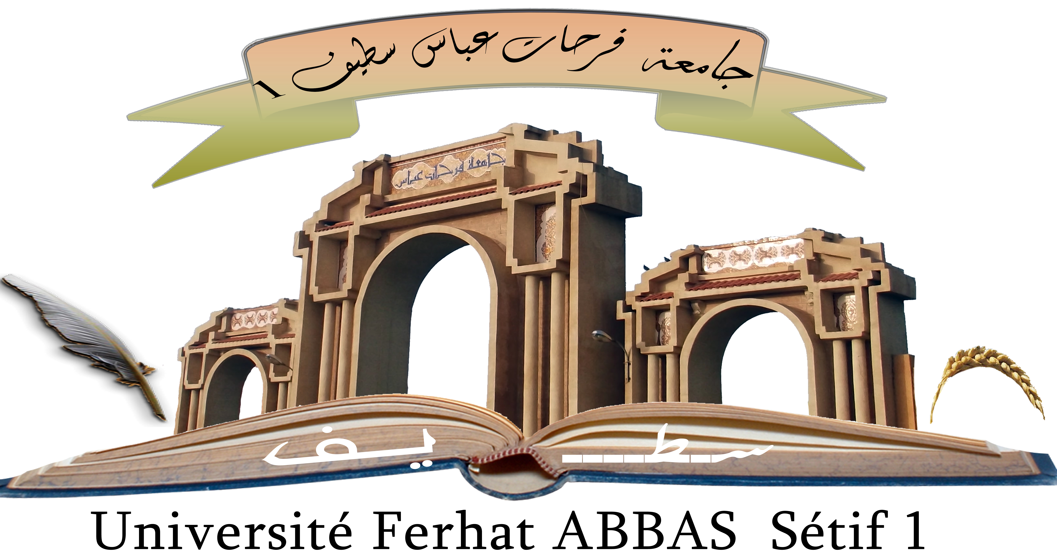
Université Ferhat Abbas Sétif 1
Faculté des Sciences de la
Nature et de la Vie

الجمهورية الجزائرية الديمقراطية الشعبية
وزارة التعليم العالي والبحث العلمي

جامعة فرحات عباس، سطيف 1
كلية علوم الطبيعة والحياة

Department of Plant Biology and Physiology
Memory
N°………………………………/SNV/2025
Prepared by
BEKHOUKH Aya
AISSAOUI Loualoua
For obtaining the diploma of
MASTER
Field : Biological Sciences

Specialty : Biodiversity and Plant Physiology

Titled:

Ethnobotanical survey of Moringa oleifera L

Publicly supported on: 24/06 /2025

Before the Jury:
President : LAOUER Hocine Pr. UFA Setif 1
SUPERVISOR: LAMAMRA Mebarka MCA.UFA Setif 1
Examiner : BERGHOUT Nihed MCA.UFA Setif 1

College year: 2024/2025

Introduction
The scientific use of plant-derived preparations for prevention and treatment is termed Phytotherapy. This approach constitutes an evidence-based medical methodology, distinct from traditional practices relying solely on cumulative knowledge, through its foundation in rigorous biological studies and controlled clinical trials (Falzon and Balabanova, 2017). Credit for coining the term and establishing the modern concept of phytotherapy is attributed to French physician Henri Leclerc in the early 20th century, while the seminal textbook "Précis de Phytothérapie" by German botanist Rudolf Fritz Weiss in the 1960s significantly contributed to consolidating its scientific standing (Ferreira et al., 2014).
Numerous plants possess a long history of medicinal use across civilizations. Among these, Moringa oleifera has garnered increasing attention in recent decades due to its rich nutritional profile and diverse therapeutic properties (Leone et al., 2015). Contemporary scientific studies indicate that Moringa may play a significant role in managing metabolic disorders, including insulin resistance and obesity. Preliminary research suggests its extracts can regulate lipid and glucose absorption while modulating metabolic pathways (Vergara-Jimenez et al., 2017; Tshingani et al., 2020;). The application of Moringa as an adjunct in weight management programs represents a prevalent use case warranting further clinical research to precisely elucidate its efficacy and mechanisms of action (Saini et al., 2022).
Building upon this foundation, this study aimed to conduct an ethnobotanical evaluation of the medicinal applications of M. oleifera. Fieldwork was implemented across three principal areas in Setif Province (Algeria), Setif City, El Eulma, and Ain Oulmane Municipality. Data collection employed a dual-method approach:
- Semi-structured interviews: Conducted with local herbalists to document traditional knowledge regarding plant parts utilized (leaves, seeds, roots), preparation methods (infusion, decoction, powder), and primary therapeutic indications.
- Specially designed online questionnaire: Administered to consumers using Moringa to assess subjective experiences, dosage regimens, perceived efficacy, and potential adverse effects.
This study is structured as follows:
- Chapter 1 (bibliographic part): Presents a comprehensive overview of phytotherapy, ethnobotany, the botanical, phytochemical, and therapeutic properties of M. oleifera, supported by current scientific literature.
- Chapter 2 (Methodology): Details the study areas (Setif, El Eulma, Ain Oulmene), target populations (herbalists, online consumers), data collection instruments (interview protocol, online questionnaire), and statistical analysis procedures.
- Chapter 3 (Results and Discussion): Reports findings on herbalists' traditional knowledge and consumer usage patterns of Moringa, discussed in context with available scientific evidence.
- Conclusion: Summarizes key findings and provides recommendations for future research and practical applications.
This study aims to bridge the gap between traditional practices and scientific evidence concerning M. oleifera utilization, establishing a documented ethnobotanical database for the study region.

TABLE OF CONTENTS
Acknowledgment
Dedication
Abstract
الملخص
Résumé
List of abreviations
List of figures and tables
Introduction | 01
Chapter 1: Bibliographic synthesis
1. Ethnobotany | 03
1.1. Definition and Historical Context | 03
1.3. Aims and Applications | 03
1.2. Types of Ethnobotany | 04
2. Phytotherapy | 04
2.1. Definition and Global Relevance | 04
2.2. Traditional and Modern Approaches | 04
2.3. Challenges in Algeria | 04
3. Medicinal Plants | 04
3.1. Definition and Significance | 04
3.2. Preparation and Conservation | 05
3.3. Risks and Future Directions | 05
4. Generalities on Moringa oleifera | 05
4.1. Historical | 05
4.2. Geographical Distribution | 05
4.3. Botanical Description | 06
4.3.1. Leaves | 07
4.3.2. Flowers | 07
4.3.3. Fruits | 08
4.3.4. Seeds | 09
4.3.5. bark | 09
4.4. Taxonomy and Classification | 10
4.5. Nutritional Composition | 10
4.6. Phytochemical Composition | 13
4.7. Traditional Uses | 20
4.8. Non-Food or Medicinal Uses | 20
4.9. Dietary Use | 21
4.10. Agricultural Use | 21
4.10.1. Water Purification | 21
4.10.2. Acceleration of Plant Growth | 22
5. Medicinal Properties of M. oleifera | 22
5.1. Antimicrobial and Antifungal Activity | 22
5.2. Anti-Inflammatory Activity | 23
5.3. Oxidative Stress Protection | 24
5.4. Anti-Oxidant Activity | 24
5.5. Anti-Cancer Activity | 25
5.6. Fertility and Anti-Fertility Activity | 25
5.7. Hepatoprotective Activity | 26
5.8. Cardiovascular Activity | 26
5.9. Neuropharmacological Activity | 27
5.10. Immunomodulatory Activity | 28
5.11. Hematological Activity | 28
5.12. Anti-Obesity Activity | 28
5.13. Anti-Allergic Activity | 29
5.14. Anti-Diabetic Activity | 29
Chapter 2: Material and methods
1. Study Characterization | 31
1.1. Type of Study | 31
1.2. Period of the Study | 31
2. Description of the Studied Population | 31
2.1. Location and Population Density | 31
2.2. Age and Gender Structure | 33
2.2.1. Setif | 33
2.2.2 Ain Oulmene | 34
2.2.3. El Eulma | 34
2.3. Socioeconomic Context | 25
2.3.1 Setif | 35
2.3.2 Ain Oulmene | 35
2.3.3. El Eulma | 26
2.4. Link Between Demographics and the Study | 36
3. Statistical Analysis | 37
3.1. Data Processing | 37
3.2. Expression of Results | 37
4. Ethnobotanical Study | 37
Chapter 3: Results and discussion
1. Profile of the Studied Population | 40
1.1. Distribution of Respondents | 40
1.2. Distribution of Herbalists by Age | 41
1.2.1. In Setif | 41
1.2.2. In Ain Oulmane | 41
1.2.3. In El Eulma | 42
1.3. Education Level of Herbalists | 43
1.3.1. In Setif | 43
1.3.2. In Ain Oulmane  1.3.3. In El Eulma | 43  44
1.4. Distribution of Herbalists by Gender | 45
1.5. Distribution of Surveyed Individuals by Age | 46
1.6. Distribution of Surveyed Individuals by Education Level | 47
1.7. Distribution of Surveyed Individuals by Gender | 48
1.8. Common Name | 48
1.9. Parts Used | 49
1.10. Forms of Plant Use | 50
1.11. Methods of Preparation | 50
1.12. Preparation Time | 51
1.13. Quantity Used | 52
1.14. Duration of Use | 52
1.15. Main Uses | 53
1.16. The Most Common Diseases Treated by the Plant | 54
1.17. Potential Side Effects of M. oleifera | 55
1.18. Groups for Whom M. oleifera Use is Contraindicated | 56
1.19. Cosmetic uses | 57
Discussion | 58
2. Sociodemographic Characteristics of Herbalists | 58
3. Sociodemographic Characteristics of Medicinal Plant Consumers (Online Survey) | 59
4. The educational Level of herbalists | 60
5. Distribution of Surveyed Individuals by Education Level | 61
6. Distribution of Herbalists by Gender | 61
7. Common Name | 62
8. Parts Used of Plants | 63
9. Forms of Plant Use | 64
10. Methods of Preparation | 64
11. Quantity Used | 65
12. Medicinal Benefits of M. oleifera | 66
13. Potential Side Effects of M. oleifera | 68
14. Groups for Whom M. oleifera Use is Contraindicated | 68
15. Cosmetic uses | 69
Conclusion | 71
Bibliographic References | 73
Annexe
Abstract
الملخص
Résumé

Abstract
Moringa (Moringa oleifera L) is a tropical tree of high nutritional and medicinal value, renowned for its diverse therapeutic properties. An ethnobotanical survey was conducted in the regions of Sétif, Aïn Oulmene, and El Eulma between February and April 2025. It involved 132 participants, primarily sellers of medicinal plants, with the aim of documenting the traditional uses of Moringa oleifera L. The results revealed that Moringa oleifera is used by 39% of participants to boost immunity, 35% to regulate blood sugar, 13% to improve digestive health, 47% to treat anemia, and 30% to treat infections. Methods of use included: infused moringa leaves (1 to 3 cups per day, with one teaspoon per 250 ml of water), daily use of powder (0.5 to 2 teaspoons), 1 to 2 capsules per day (500 mg each), seed oil for external use (skin and hair), and fresh leaves in the diet (20 to 30 g per day). Leaves constitute the primary part used (95%), with warnings against the use of roots due to their toxicity (15%). Gastrointestinal side effects (nausea, diarrhea) were reported for intakes exceeding 10 g/day, with specific warnings for pregnant women, children, and thyroid patients.
Keywords: ethnobotanical survey; Moringa oleifera L; Setif; Ain oulmene; El Eulma

الملخص
تُعد المورينجا (Moringa oleifera) شجرة استوائية ذات قيمة غذائية وطبية عالية، تُعرف بخصائصها العلاجية المتنوعة, لهذا أُجريت دراسة إثنوبوتانية في مناطق سطيف، عين ولمان، والعلمة بين فبراير وأبريل 2025، وشملت 132 مشاركًا، معظمهم من بائعي النباتات الطبية، بهدف توثيق الاستخدامات التقليدية لنبتة (Moringa oleifera). وقد كشفت النتائج أن 39% من المشاركين يستخدمون المورينجا لـتعزيز المناعة، و35% لـتنظيم مستوى السكر في الدم، و13% لـتحسين صحة الجهاز الهضمي، و47% لـعلاج فقر الدم (الأنيميا)،30% لـعلاج الالتهابات. تضمنت طرق الاستخدام: أوراق المورينجا المنقوعة (كوب إلى ثلاثة أكواب يوميًا، بملعقة صغيرة لكل 250 مل من الماء)، الاستخدام اليومي لـمسحوق المورينجا (0.5 إلى 2 ملعقة صغيرة)، كبسولة إلى كبسولتين يوميًا (500 ملجم لكل كبسولة)، زيت البذور للاستخدام الخارجي (للبشرة والشعر)، والأوراق الطازجة في النظام الغذائي (20 إلى 30 جرام يوميًا). تُعد الأوراق الجزء الرئيسي المستخدم (95%)، مع تحذيرات ضد استخدام الجذور نظرًا لسميتها (15%). كما تم الإبلاغ عن آثار جانبية على الجهاز الهضمي (غثيان، إسهال) عند تناول جرعات تتجاوز 10 جرامات في اليوم، مع تحذيرات خاصة للنساء الحوامل، الأطفال، ومرضى الغدة الدرقية.
الكلمات المفتاحية: دراسة إثنوبوتانية؛ Moringa oleifera ؛ سطيف، عين ولمان، العلمة.

Résumé
Moringa oleifera L est un arbre tropical à haute valeur nutritionnelle et médicinale, réputé pour ses propriétés thérapeutiques diversifiées. Une enquête ethnobotanique est menée dans les régions de Sétif, Aïn Oulmene et El Eulma entre février et avril 2025, impliquant 132 participants, principalement des vendeurs de plantes médicinales, afin de documenter les usages traditionnels du Moringa oleifera L. Les résultats ont révélé que Moringa oleifera L est utilisé par 39 % des participants pour renforcer l'immunité, 35 % pour réguler la glycémie 13% pour améliorer la santé digestive, 47% pour traiter l'anémie, et 30% pour traiter les infections. Les méthodes d'utilisation comprenaient : les feuilles de moringa infusées (1 à 3 tasses par jour, avec une cuillère à café pour 250 ml d'eau), l'utilisation quotidienne de poudre (0,5 à 2 cuillères à café), 1 à 2 gélules par jour (500 mg chacune), l'huile de graines pour usage externe (peau et cheveux), et les feuilles fraîches dans l'alimentation (20 à 30 g par jour). Les feuilles constituent la partie principale utilisée (95 %), avec des mises en garde contre l'usage des racines en raison de leur toxicité (15 %). Des effets secondaires gastro-intestinaux (nausées, diarrhée) ont été signalés pour des prises dépassant 10 g/jour, avec des avertissements spécifiques pour les femmes enceintes, les enfants et les patients thyroïdiens.
Mots-clés : enquête ethnobotanique ; Moringa oleifera L, Setif ; Ain oulmene ; El Eulma

