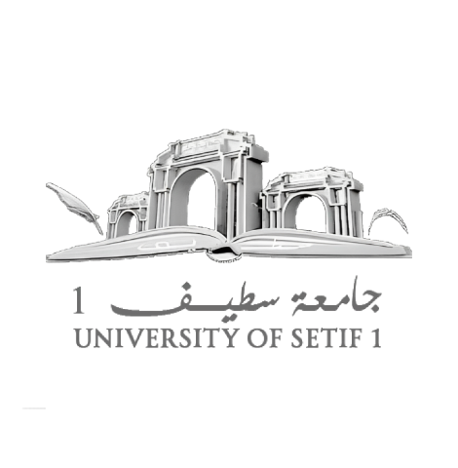
الجمهورية الجزائرية الديمقراطية الشعبية
People's Democratic Republic of Algeria
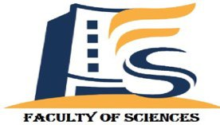

Ferhat Abbas Setif University
Faculty of Sciences
Department of Physics
Master’s Thesis
FIELD: Material Sciences.
SECTOR: Physics.
OPTION: Physics Of Materials.
Theme
Studies of the thermal stability of the tungsten silicide at different temperatures

Presented by
Henchour Ayoub
Supervisor
Pr. Derafa Achour
Members of jury:
President: Dr. ZERROUG Samir
Examiner: Pr. KERKACHE laid

2023/2024

Abstract :
In this work we studied the thermal stability and formation of tungsten silicides, produced by sputtering (PVD) on a Si(100) silicon substrate.
We used rapid thermal annealing throughout the study, due to its effective effect (600°C, 800°C, 900°C) on the formation of silicides. During this study, the emphasis is placed on the effects of oxygen and the effects of template and also the effect of temperature on the formation of silicides. Then characterized by X-ray diffraction (XRD ). The main results can be summarized as follows:
Oxygen has an effective effect in delaying the formation of silicides and oxygen favors the β-W structure.
The effect of the template played an important role in accelerating the reaction, and a distinctive (W-Mo)3Si phase appeared at low temperature.
We observed that the hexagonal phase is formed at 600°C, after raising the temperature to 800°C, we notice a complete change in the structure from hexagonal to tetragonal, this explains that the hexagonal structure is unstable when the temperature is raised, unlike the tetragonal structure.
Key words: Silicide, Tungsten, RTA, DRX, FPP, WSi2, MoSi2

