
People`s democratic republic of Algeria
Ministry of higher education and scientific research Setif 1. University -Farhat ABBAS
Faculty of Economic, Commercial and Management
Department: Commercial Science
Submitted as part of the requirements for obtaining a master`s degree in commercial sciences
Speciality: Digital marketing
Thesis title:
The role of AI in optimizing Social Media Ad targeting for Algerian audiences

Thesis by: Malak NAIDJI

Academic year: 2024/2025
Supervisor:
Dr: Fawzia BOUSAFSAF
Discussion committee
Associate professor (B) Manel REBBOUH | Chairperson
Associate professor (A) Fawzia BOUSAFSAF | Supervisor
Professor Nasser BOUCHAREB | Examiner



01


The digital era has significantly transformed the advertising landscape, mainly driven by the growth of social media. Ads are no longer random; they now depend on precise targeting to reach the appropriate audience. In this context, Artificial Intelligence has become a key technology, revolutionizing digital marketing by improving campaign effectiveness.

This study aims to examine the role of AI in enhancing ad targeting across social media platforms, with a particular focus on the Algerian audience's view.
We want to understand how these technologies influence Algerian consumer engagement and awareness, and to identify the opportunities and challenges they present in the local context.

02



Is there a statistically significant impact at a significance level of 0.05 for Artificial Intelligence on improving the effectiveness of targeted advertisements via social media platforms from the perspective of the target audience in Algeria?



01 02 03

Does artificial intelligence impact
the accuracy of ad targeting on social media from the perspective of the target audience in Algeria at a significance level of 0.05?
Does artificial intelligence impact the Behavioral influence on social media from the perspective of the target audience in Algeria at a significance level of 0.05?
Does artificial intelligence impact the User experience on social media from the perspective of the target audience in Algeria at a significance level of 0.05?



04 05
Does artificial intelligence impact

Are there differences in the impact of



the Economic efficiency on social media from the perspective of the target audience in Algeria at a significance level of 0.05?
03
artificial intelligence on improving the
effectiveness of ad targeting on social media based on the personal information (age, gender, and educational level) of the Algerian audience at a significance level of 0.05?


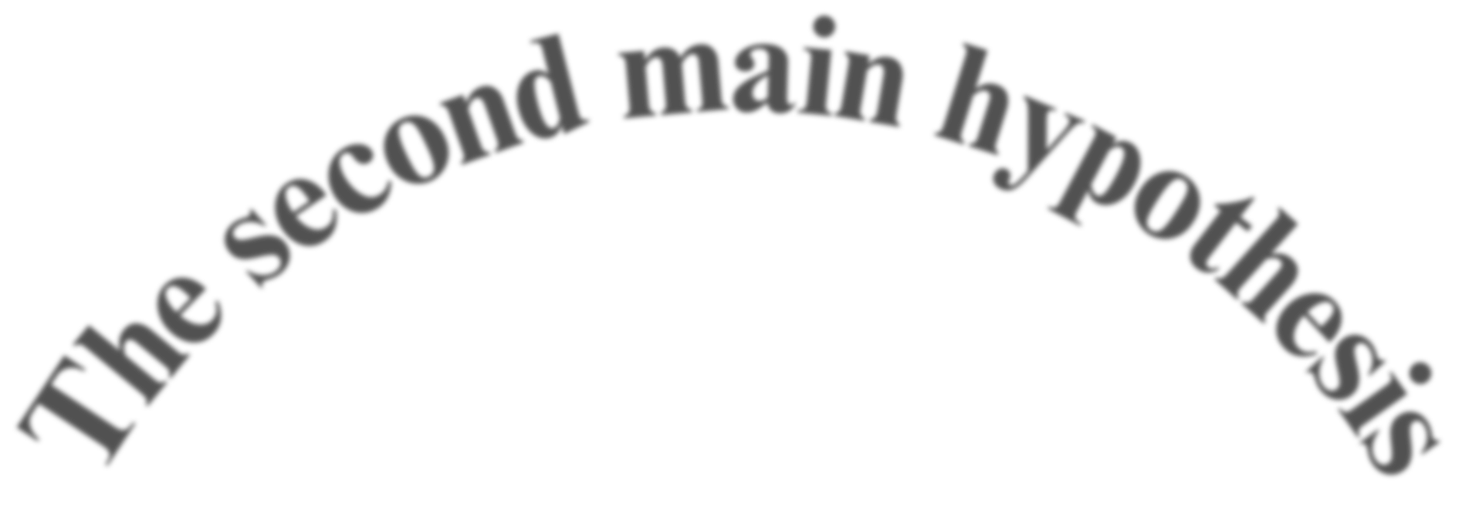
04
i
a
n
i
n
h
h
y
y
p
p
o
o
t
t
h
h
e
e
s
s
i
i
s
s
T
T
h
h
e
e
s
f
e
i
r
c
s
o
t
n
d
m
m
a

There is a statistically significant impact at a significance level of 0.05 for Artificial Intelligence on improving the effectiveness of ad targeting on social media platforms from the perspective of the target audience in Algeria.

There are statistically significant differences at a significance level of 0.05 for Artificial Intelligence in improving the effectiveness of ad targeting on social media platforms based on the personal information of the Algerian audience.

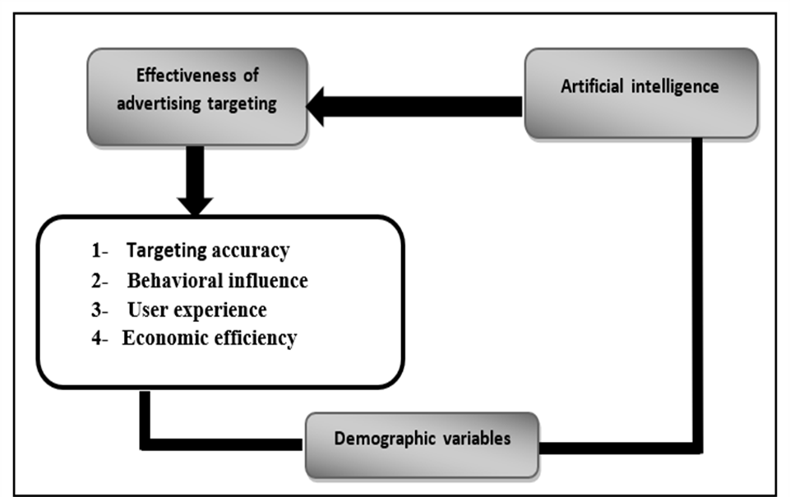



07


01

The importance of the study is evident in its clarification of the role played by artificial intelligence in advertising and how it improves the targeting process.

07



Ultimately, providing
insights and recommendations for marketers and businesses operating in the Algerian market.
08
04
02

Examining various AI applications in social media advertising



Understanding how AI algorithms analyze user data, identify patterns, and enable hyper-personalized content delivery in the Algerian context.
01

Identifying the key benefits and potential challenges associated with leveraging AI for social media ad targeting in Algeria.
03

The limits of the study


Temporal Limits
01
Spatial limits

May 13, 2025, to May 27, 2025 the geographical scope of this study is confined to Algeria
09
02

Objective limits
03
main goal is to determine AI's impact on targeted ad effectiveness from the Algerian target audience's perspective,

Study difficulties
10


01
Limited Data Collection Period
Limited Public Understanding of AI
02

03
Difficulty in obtaining a field internship at
an economic institution

Technical Glitches
04

Procedural definitions
08
AI is computers acting like humans to solve tough problems and work smarter.
Social media ads are paid messages on social platforms targeting specific audiences to achieve marketing goals.
Targeting ads means showing specific ads to certain groups of people based on their characteristics and data.

Procedural definitions
08
Digital campaigns are online marketing efforts using digital tools to promote and engage.
Targeting accuracy is hitting the right audience in a marketing campaign to maximize effectiveness.
Behavioral influence is how marketing affects consumer actions and attitudes.

Procedural definitions
08
Economic efficiency in ad targeting means precisely hitting the right audience to maximize ad impact.
User experience (UX) is the overall satisfaction and interaction users have with a digital product or service.

Study population
includes all Algerian people who use social media.

The study sample
The study sample was selected from 257 responses

Study tool
Primary data for this study was gathered through a questionnaire.
The questionnaire was specifically designed for a sample of Algerian social media users

EMPIRICAL RESULTS
the acceptance of the alternative hypothesis These findings are consistent with a previous study titled "Impact of AI on Personalised Targeting in Social Media Advertising "

For the first sub-hypothesis, the regression equation revealed a positive relationship, indicating that increased use of artificial intelligence leads to improved accuracy in targeting advertisements on social media platforms.

EMPIRICAL RESULTS
The regression equation revealed same positive effect was observed on behavioural influence, user experience, and economic efficiency.

The results A one-way ANOVA test
leading to the acceptance of the null hypothesis,
which indicates that there are no statistically significant differences at the 0.05 level
regarding the impact of artificial intelligence on the effectiveness of ad targeting across these demographic groups.

RECOMMANDATIONS
Enhance Public Awareness of AI

and businesses should prioritise transparency in data collection and usage

Future research should aim for a larger and more diverse sample,

Adding qualitative methods, such as interviews or focus groups, to quantitative data provides deeper insights into user experiences and perceptions of AI-targeted ads.

Conduct case studies with businesses to analyze their AI implementation in digital marketing, providing practical examples and validating theories.



